**Project Development Phase**

**Delivery of Sprint - 3**

|  |  |
| --- | --- |
| **Date** | 07 November 2022 |
| **Team ID** | PNT2022TMID10041 |
| **Project Name** | AI based discourse for Banking Industry |

# Creating General Query Action

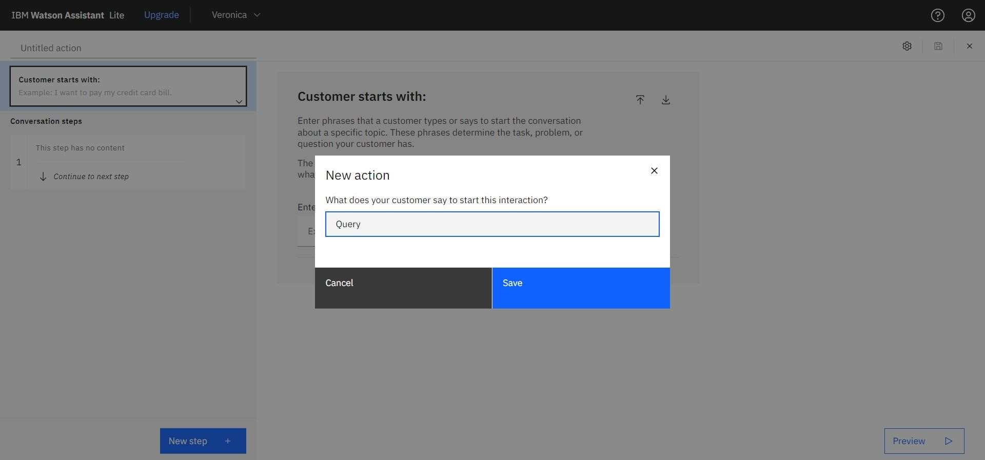

Adding steps in Query action to handle queries regarding Bank working hours, Currency conversion policy,

Storage locker facility, CIBIL score, list of all branches, nearest available branch, etc.,

# Creating Net Banking Action

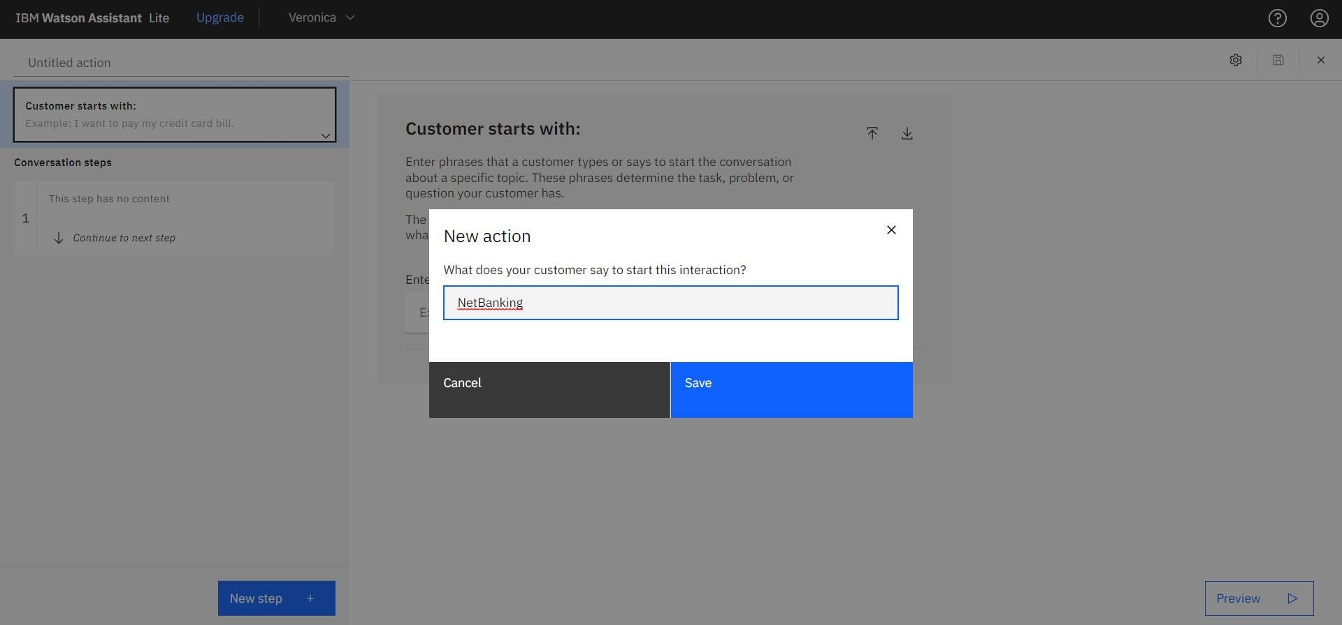

Adding steps in Net Banking Action skill to handle queries of customers regarding significance and issues of net banking.

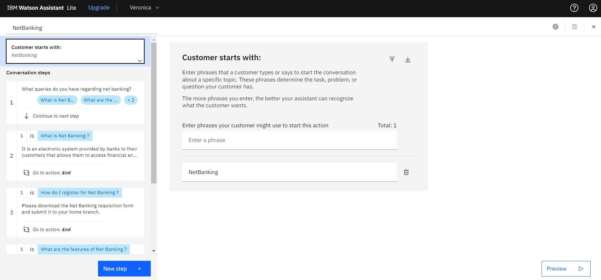

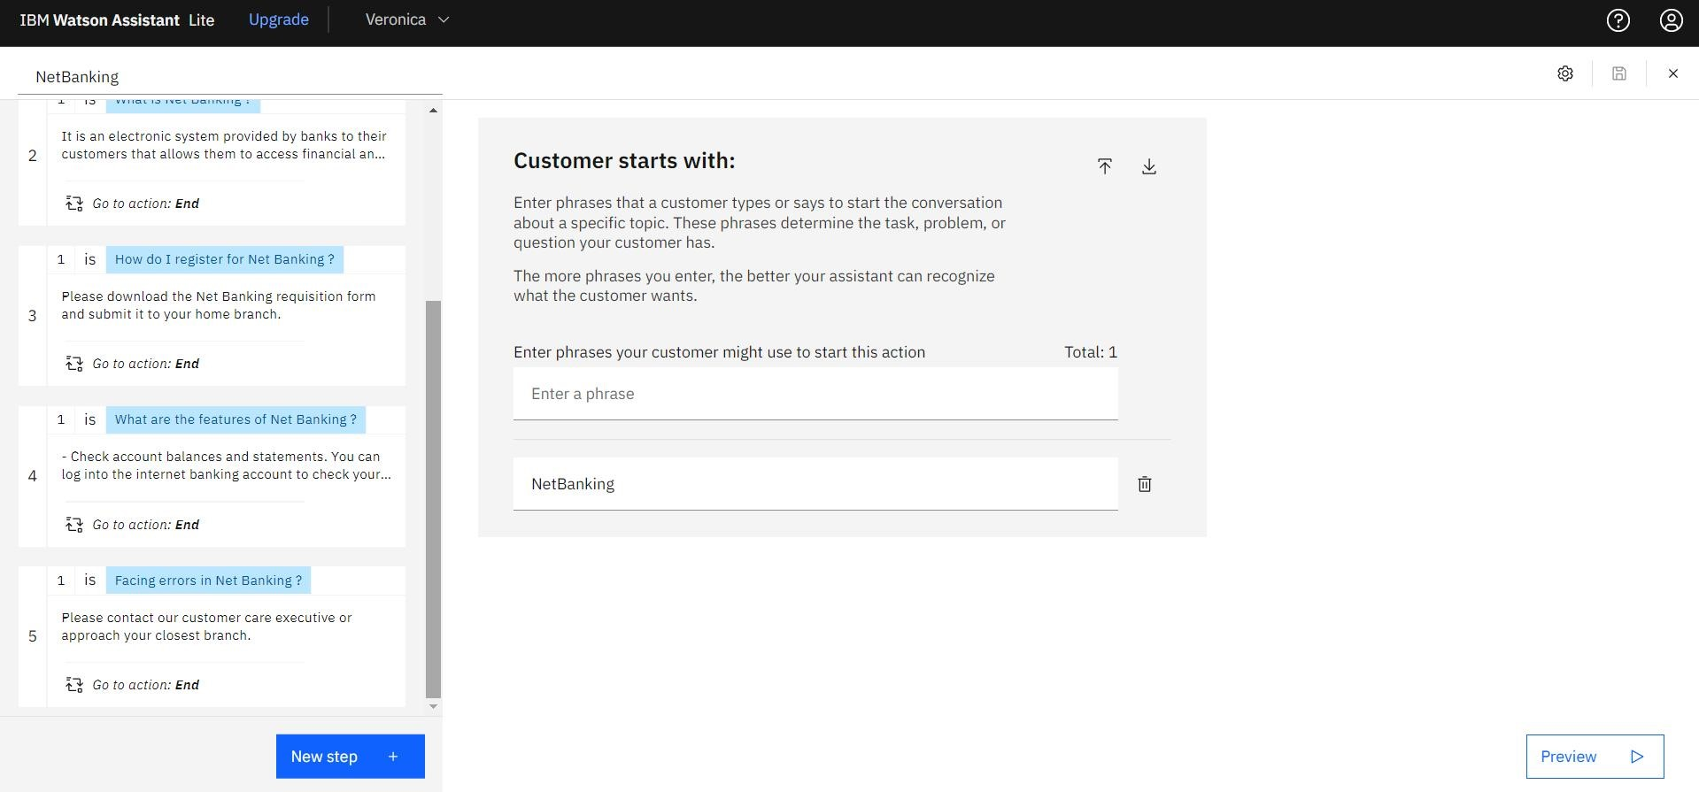

In addition to this greeting, end greeting ,index and end actions are also created.

